Potentially Serious Injury (PSI)
The MHSA is committed to assisting our members with ongoing information on topics within the industry and implemented as per legislation. Potential for Serious Injury was introduced to Alberta OHS in June 2018. The information provided is up to date based on reports released on January 4, 2022.

Reported PSIs in Alberta
Statistics shown below provide evidence of a steady decline in manufacturing reporting since the introduction of PSI reporting in 2018.
*MHSA Member companies refers to all auto-levied members through WCB – Industry codes 30100 and 62500
MHSA - Number of PSIs, by month and year
June through October are reported as higher incident months. Manufacturing projects tend to increase during these periods which increases staffing and hazardous work being conducted.
Note: PSI reporting began on June 1, 2018

Top 10 Industries reporting PSIs throughout the Province
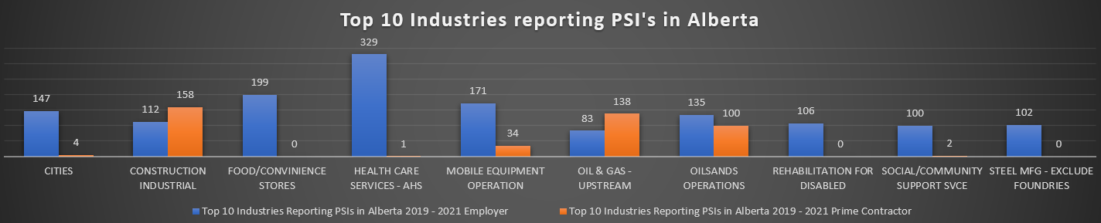
The top 3 industries reporting PSIs reported between 2019-2022 include Health Care Services (330 total), Construction Industrial (270 total), Oilsands Operations (235 total). Steel Manufacturing is 9th with 102 total reports.

Top 10 Types of Reported PSI Incidents by Year
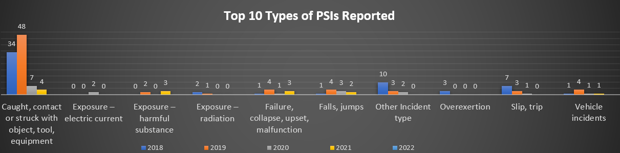
The Top Three Types of PSIs reported between 2018 – 2022 include: Caught, contact, or struck with object, tool, equipment (93 Total); Other incident Type (15 Total); Slip, Trip (11 Total)

Top 10 PSIs Incident Sources
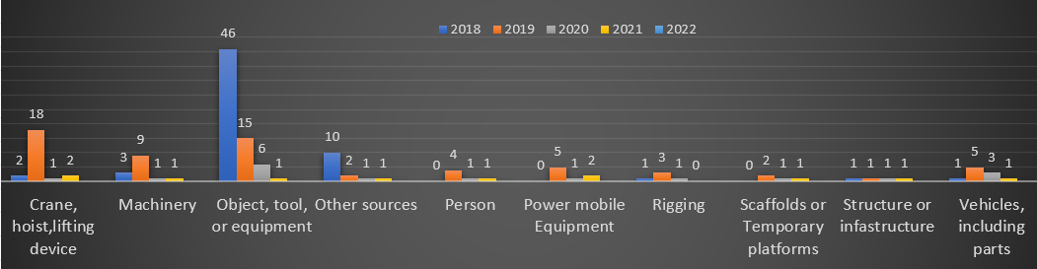
The top Three Sources of PSIs 2018-2022 include: Object, tool, or equipment (68 total); Crane, hoisting, lifting device (23 total); Machinery (14 total); Other source (14 total).

Reporting PSI and Prevention of PSI Recurrence
Reporting and investigating Potentially Serious Incidents (PSIs) OHS information for workers, employers and prime contractors can be done through:
Report potentially serious incidents | Alberta.ca
If you have a have a PSI and are unsure about any steps, please contact MHSA and we’ll help you throughout the process.
Corrective Actions
In the event of an incident at the workplace including PSIs, corrective actions must be identified and implemented to prevent that type of incident of recurring. A proper investigation, including evaluation of current controls and implementation of corrective actions, is critical in the reduction of incidents and injuries in the workplace.
Communication of results of PSI investigations should be communicated to all levels of an organization to provide essential information needed to prevent incidents, injuries and even fatalities from occurring in the workplace.”
How MHSA can help
We offer a variety of assistance to companies through training, advising, site visits and mentoring to help employers understand their responsibilities and requirements for PSI reporting in Alberta. For more information visit http://mhsa.ab.ca or reach out to a Regional MHSA office and speak with one of our knowledgeable safety advisors today!
Available Courses through MHSA relevant to PSI Reporting

- Basic Rigging | - Hazard Assessment | - Overhead Crane Operator
- Forklift Operator | - Navigating OHS | - Principles of Workplace Investigation
- Responding to OHS Investigations | - Leading Safety | - Musculoskeletal Disorder Awareness
- Safety Basics
Register for courses via our website by visiting: https://www.mhsa.ab.ca

References
Alberta Labour, Occupational Health and Safety Act, June 1, 2018, http://www.qp.alberta.ca/1266.cfm?page=O02P1.cfm&leg_type=Acts&isbncln=978077980049 0&display=html.

Alberta Labour, Reporting and Investigating Potentially Serious Incidents (PSI), Bulletin, https://ohs-pubstore.labour.alberta.ca/li016-1

Alberta Labour Report potentially serious incidents (PSI) website: https://www.alberta.ca/report-potentially-serious-incidents.aspx

Energy Safety Canada
www.energysafetycanada.com/_Resources/Guidelines-Reports/POTENTIALLY-SERIOUS-INCIDENT-(PSI)-GUIDELINE

Potential Serious Incidents Toolbox Presentation (energysafetycanada.com)

WCB
Alberta Potentially serious incident (PSIs) Report October 1, 2021
Alberta Potentially serious incident (PSIs) report -Manufacturers Health & Safety Association PSI Report October 1, 2021

OHS Changes/ Updates
BREAKING: Changes to OHS Legislation Announced — Manufacturers' Health & Safety Association (mhsa.ab.ca)
