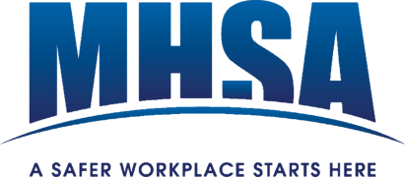
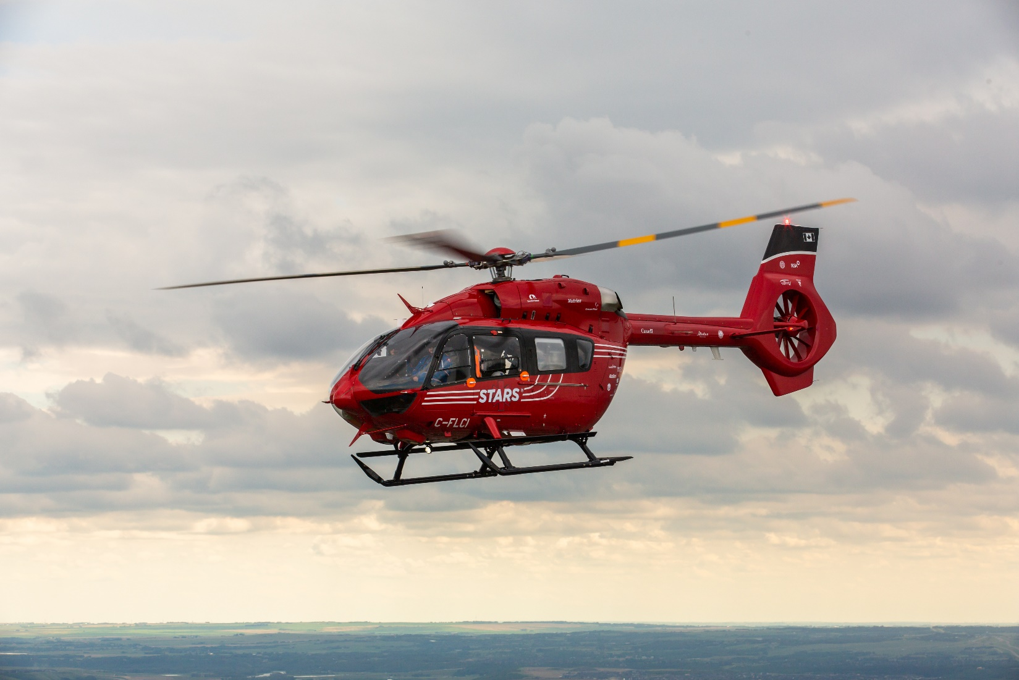

Golf Tournament Sponsorship

nament Sponsorship

Partner with the MHSA in supporting STARS air ambulance at this year’s charity golf tournament!
Contact maggie@mhsa.ab.ca to sign up

THE GIFT OF FLIGHT
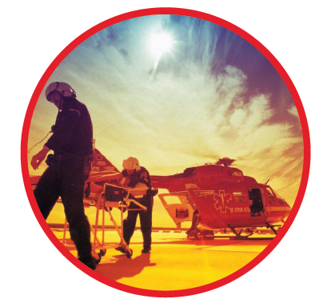
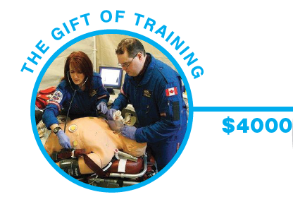
SPONSORSHIP PACKAGES
Help us help STARS fight for life!

Why Sponsor?
- Showcase your business and/or products.
- Get noticed by peers, industry partners and the H&S community.
- Be recognized as a key supporter to an admirable cause!
$5600
Gold STARS Sponsor
The gold STARS package gives the sponsor the opportunity to gain full recognition during the tournament as well as the ability to interact face – to – face with golfers during the event. Have your company featured throughout the tournament at every turn. Sponsorship includes:
- Four (4) golfer registrations (including meals)
- 2 Additional Dinner reservations (for those tending the hole activity)
- Choice hole designation for golf activities and giveaways
- Logo banner (yours to keep following the event)
- Signage throughout the course and banquet
- Full page company bio in the golf program
- Verbal recognition of sponsorship during the banquet
- Option to provide a custom goody bag to all attendees (think candy, a water bottle or other item, to be distributed by the sponsor during the banquet event.)
$2200

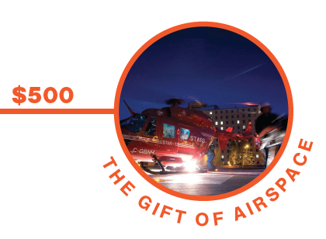
Banquet Sponsor
The banquet sponsor package gives the sponsor the opportunity to gain recognition during the golf banquet as the exclusive supporter of the golf banquet. Personally feature your company and all the things you do! Sponsorship includes:
- Four (4) golfer registrations (including meals)
- Logo banner (yours to keep following the event)
- Speech or presentation opportunity at the banquet
- Full page company bio in the golf program
- Verbal recognition of sponsorship during the banquet
- Opportunity to create a signature drink option for golfers at the banquet (*Must be agreed upon with Innisfail Golf Club prior to the event.)
$1800
Silver STARS Sponsor
The silver STARS package gives the sponsor the opportunity to gain recognition during the tournament as well as the ability to interact face – to – face with golfers during the event. Sponsorship includes:
- Four (4) golfer registrations (including meals)
- 2 Additional Dinner reservations (for those tending the hole activity)
- Choice hole designation for golf activities and giveaways
- Logo banner (yours to keep following the event)
- Full page company bio in the golf program
- Verbal recognition of sponsorship during the banquet
- Option to supply a swag item to be incorporated into the golfer registration package ( think sunscreen, divot tool, your favorite lip balm or other. *Items must be delivered to the MHSA no later than 2 weeks prior to the event.)
$2000

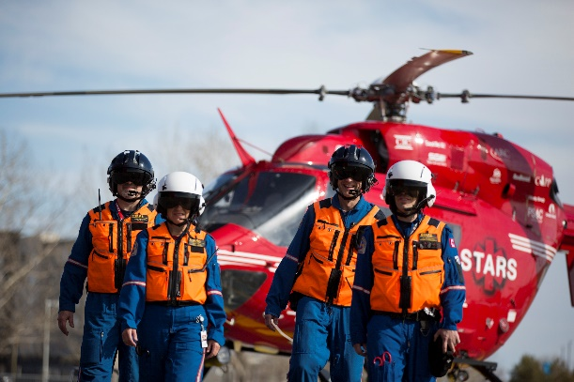
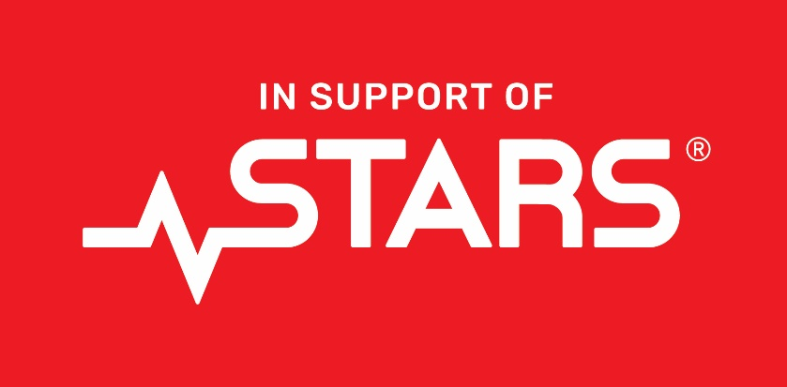
Thirst Quencher Sponsor
Showcase your brand! The thirst quencher sponsor will be recognized by each golfer on the course. Station your representatives on the green to mingle and providing a much-needed refreshing drink of water or electrolyte beverages on a hot summers’ day. (*Alcohol is also permitted with prior consent from Innisfail golf club. Sponsor must arrive no later than 1 hour prior to the event start time. MHSA golfers can be identified with blue wristbands.) Sponsorship includes:
- 2 dinner reservations (for those tending the hole activity)
- Exclusive recognition for sponsorship of refreshments during the game
- Logo signage at registration & on the green (yours to keep following the event)
- ½ page company bio in the golf program
- Verbal recognition of sponsorship during the banquet
$1000 | only 4 sponsorships available
Lunch Sponsor
Don’t miss out on this fantastic networking opportunity! The lunch sponsorship provides golfers with the late morning meal that will be served by the golf club. If the sponsor so chooses, they can instead bring their own BBQ and meal option to serve to event guests. (*Must be agreed upon with Innisfail golf club ahead of time. Sponsor must arrive no later than 1 hour prior to the event start time. MHSA golfers can be identified with blue wristbands.) Sponsorship includes:
- Two (2) golfer registrations (including meals)
- Logo signage at registration and lunch set-up areas (yours to keep following the event)
- ½ page company bio in the golf program
- Verbal recognition of sponsorship during the banquet
$1500 | only 2 sponsorships available
PACKAGE | GOLF REGISTRATION | DINNER | LOGO SIGNAGE | BANQUET RECOGNITION | GOLF PROGRAM BIO
Gold STARS | 4 people | 6 people | Yes | Recognition | Full page
Silver STARS | 4 people | 6 people | Yes | Recognition | Full page
Banquet | 4 people | 4 people | Yes | Recognition & Presentation | Full page
Lunch | 2 people | 2 people | Yes | Recognition | Full page
Thirst Quencher |  | 2 people | Yes | Recognition | ½ page
Activity Hole |  | 2 people | Yes |  | ½ page
Big Ticket Prize |  |  | Yes | Recognition | Shout out
Activity Hole Sponsor
Make a lasting impression by sponsoring an activity on the green! Challenge the players by giving them a handicap or having them try out their happy Gilmour swing. You have the freedom to be creative and have fun. Sponsorship includes:
- 2 dinner reservations (for those tending the hole activity)
- Choice of activity or contest (sponsor must provide all supplies)
- Logo signage on the green (yours to keep following the event)
- ½ page company bio in the golf program
- Verbal recognition of sponsorship during the banquet
- Option to hand out logo swag or merchandise to players during game play (*MHSA golfers can be identified with blue wristbands.)
$800 | limited sponsorships available

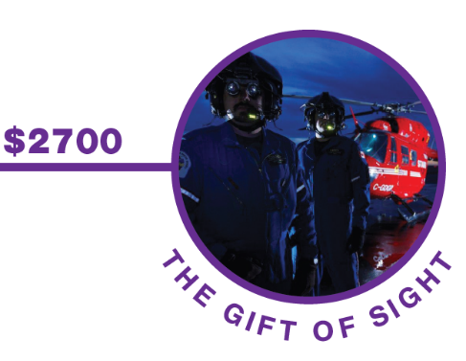
SPONSORSHIP AT A GLANCE
Big Ticket Prize Sponsor
Do you manufacture an item that you’d love to share? Or have an item that you would like to donate? Raffle it off during the golf banquet! Decorate your item with your company logo to showcase your generous donation. (*Minimum $200 value per prize donation.) Sponsorship includes:
- Advertising for your business and products
- Logo signage on raffle prize (*to be supplied by each sponsor)
- Special mention in the golf program
- Verbal recognition of sponsorship during the banquet to recognize your generosity

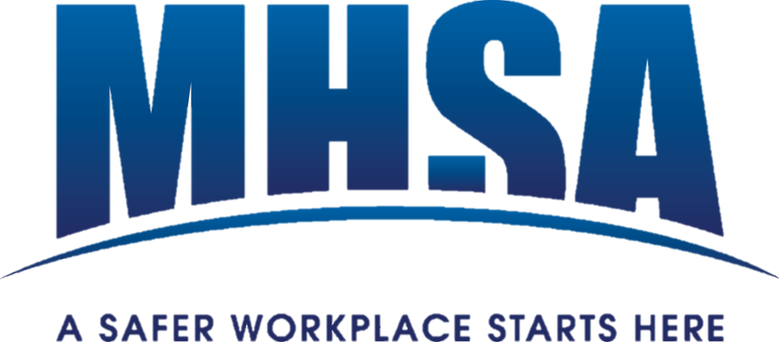
Company Name:
Company Rep. Name:
Email: |  |  |  |  | Phone #:
Sponsorship type: |  |  | Please provide:
☐ | Gold STARS |  | ☐ | Names of golfers & hole attendees
 |  |  | ☐ | Specifics of golf hole activity
 |  |  | ☐ | Copy of company logo (Jpeg or PDF)
 |  |  | ☐ | Company Bio write-up
 |  |  | ☐ | Swag bag giveaway (optional)
Sponsorship type: |  |  | Please provide:
☐ | Silver STARS |  | ☐ | Names of golfers & hole attendees
 |  |  | ☐ | Specifics of golf hole activity
 |  |  | ☐ | Copy of company logo (Jpeg or PDF)
 |  |  | ☐ | Company Bio write-up
 |  |  | ☐ | Swag giveaway item (optional)
Sponsorship type: |  |  | Please provide:
☐ | Banquet |  | ☐ | Names of golfers
 |  |  | ☐ | Copy of presentation (optional)
 |  |  | ☐ | Copy of company logo (Jpeg or PDF)
 |  |  | ☐ | Company Bio write-up
 |  |  | ☐ | Signature drink suggestions (optional)
MHSA CHARITY GOLF TOURNAMENT
COMMITMENT TO SPONSOR
Sponsor companies must complete this 2-page form in full and provide the information as requested to get the full benefits of the sponsorship. For any questions, do not hesitate to reach out to your regional MHSA office.

MHSA CHARITY GOLF TOURNAMENT
COMMITMENT TO SPONSOR

Sponsorship type: |  |  | Please provide:
☐ | Lunch |  | ☐ | Names of golfers
 |  |  | ☐ | Copy of company logo (Jpeg or PDF)
 |  |  | ☐ | Company Bio write-up
 |  |  | ☐ | Bringing own BBQ unit (optional - please notify us. *Permission must be granted by IGC)
Sponsorship type: |  |  | Please Provide:
☐ | Thirst quencher |  | ☐ | Names of hole attendees
 |  |  | ☐ | Item being supplied (i.e.: water, Gatorade, etc.*Alcohol must be approved by IGC)
 |  |  | ☐ | Copy of company logo (Jpeg or PDF)
 |  |  | ☐ | Company Bio write-up
Sponsorship type: |  |  | Please provide:
☐ | Activity hole |  | ☐ | Names of hole attendees
 |  |  | ☐ | Specifics of golf hole activity
 |  |  | ☐ | Copy of company logo (Jpeg or PDF)
 |  |  | ☐ | Company Bio write-up
 |  |  | ☐ | Swag/merch to giveaway (optional)
Sponsorship type: |  |  | Please provide:
☐ | Big ticket prize |  | ☐ | Copy of company logo (Jpeg or PDF)
 |  |  | ☐ | Brief write-up of company & item being provided & its approximate value (If donating more than one item, please specify which items are to be bundled and which to package separately or pre-package in clear wrap.)
Please return this form to the MHSA at your earliest convenience by emailing maggie@mhsa.ab.ca.
Sponsorship packages with limited availability will be granted on a first-come-first-served basis.

