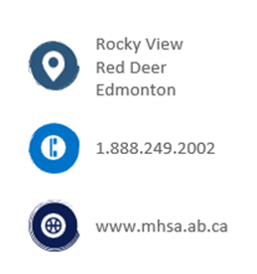 |  | Potentially Serious Incidents (PSI)  OH&S has continued to publish statistics for potentially serious incidents that have occurred across Alberta. This year reports provided to MHSA included statistics on PSIs reported for member companies of the MHSA specifically. This will allow us to provide our members with the information necessary to help prevent more of these types of incidents in our workplaces.  Total Reported PSI  From the 2023 reports published on October 2nd the province of Alberta has received a total of 366 PSI reports. At this same time last year in the report published on October 3, 2022, 1345 reports had been submitted. This is a substantial drop in reports submitted.  Including more industry codes in the reports has now created a clear picture of PSI reporting submitted over the past 5 years by companies that are members of the MHSA.  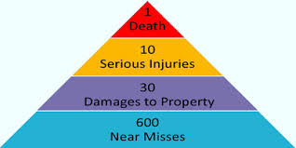  PSI reporting has the same goal as near miss reporting. All PSI reports submitted assist in the prevention of actual and serious incidents. By remaining informed employers can implement corrective actions to prevent reoccurrence of incidents of the same nature.  MHSA - Number of PSIs reported, by month and year.  With manufacturing projects increasing, staffing and hazardous work being conducted means the risk is increasing as well. Note: PSI Numbers reflected show 2021 – 2023.  In 2022 the highest number of PSIs were reported in the month of January. In 2023 thus far the month of January has had the highest number of PSIs reported with 45 recorded.  Top 10 Types of Reported MHSA PSI Incidents by Year  Review of current PSI data shows the following identified trends in type of incidents occurring:  - Caught on or in, coming into contact with or being struck with an object, tool, or equipment.  - Slip, trip  - Failure, collapse, upset or malfunction of structure, or material.  These numbers are based on PSI reports from MHSA member companies for 2023.  MHSA - Top 10 PSIs Incident Sources  The top two PSIs reported by MHSA member companies in 2022 and 2023 have been identified as:  - Environmental or related products (including fire, smoke)  - Object, tool, or equipment  We offer a variety of assistance to companies through training, advising, site visits and mentoring to help employers understand their responsibilities and requirements for PSI reporting in Alberta. If you have a have a PSI and are unsure about any steps, please contact MHSA and we’ll help you throughout the process. For more information visit http://mhsa.ab.ca or reach out to a Regional MHSA office and speak with one of our knowledgeable safety advisors today!  Available Courses through MHSA relevant to PSI Reporting  Register for courses via our website by visiting: https://www.mhsa.ab.ca  - Basic Rigging - Hazard Assessment - Responding to OHS Investigations  - Forklift Operator - Navigating OHS - Principles of Workplace Investigation  - Safety Basics - Leading Safety - Musculoskeletal Disorder Awareness  - Overhead Crane Operator - Safety Awareness - CISM  References  Alberta Labour, Reporting and Investigating Potentially Serious Incidents (PSI), Bulletin, https://ohs-pubstore.labour.alberta.ca/li016-1  Alberta Labour Report potentially serious incidents (PSI) website: https://www.alberta.ca/report-potentially-serious-incidents.aspx  Potentially Serious Incidents Surveillance Program Guide  Potentially serious incident surveillance program guide (alberta.ca)  WCB  Alberta Potentially serious incident (PSIs) Report October 1, 2021  Alberta Potentially serious incident (PSIs) report -Manufacturers Health & Safety Association PSI Report October 1, 2021  OHS Changes/ Updates  BREAKING: Changes to OHS Legislation Announced — Manufacturers' Health & Safety Association (mhsa.ab.ca)

